**Experiment no. 1**

**Aim : To study the basic continuous and discrete signals using Matlab**

**Software required : Matlab 7.0**

**Theory:**

Signals are represented mathematically as functions of one or more independent variables. Here we focus attention on signals involving a single independent variable. For convenience, this will generally refer to the independent variable as time.

There are two types of signals: continuous-time signals and discrete-time signals.

Continuous-time signal: The variable of time is continuous. A speech signal as a function of time is a continuous-time signal.

Discrete-time signal: The variable of time is discrete. The weekly stock market index is an example of discrete-time signal.

Following are some of the basic signals

1. Unit Step
2. Discrete Time Unit Step



$$u\left[n\right]=\left\{\begin{aligned}0, n<0 \\ 1, n≥0\end{aligned}\right.$$

1. Continuous Time Unit Step



$u\left(t\right)=\left\{\begin{aligned}0, t<0 \\ 1, t>0\end{aligned}\right.$

1. Unit Impulse
2. Discrete Time Unit Impulse



$$δ\left[n\right]=\left\{\begin{aligned}0, n=0 \\ 1, n≠0\end{aligned}\right.$$

1. Continuous Time Unit Impulse

$δ\left(t\right)=\lim_{∆→0}{δ_{∆}\left(t\right)}$ where $δ_{∆}\left(t\right)=\frac{u\left(t\right)-u(t-∆)}{∆}$



1. Unit Ramp
2. Discrete Time Ramp

$$r\left[n\right]=\left\{\begin{aligned}n, n≥0 \\ 0, n<0\end{aligned}\right.$$

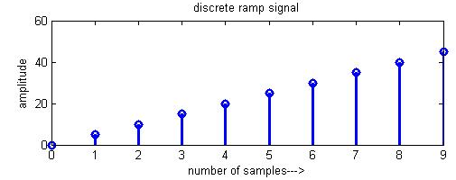

1. Continuous Time Ramp

$$r\left[t\right]=\left\{\begin{aligned}t t>0 \\ 0,t<0\end{aligned}\right.$$

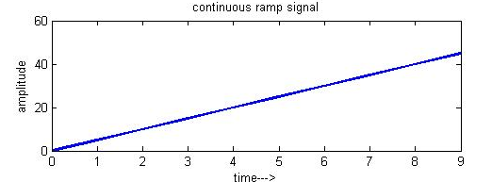

**Result:-**

**Conclusion:-**